Project School Certificate



**Title : FALSE DATA INJECTION ATTACK**

**Faculty Incharge : Dr.Rajasekaran**

**Session Duration : 10/09/2022 – 23/12/2022**

**Name : B. Chandra Sekhar**

**Roll Number :20BD1A056E**

**Class : CSE-D**

**Signature of faculty Signature of student**

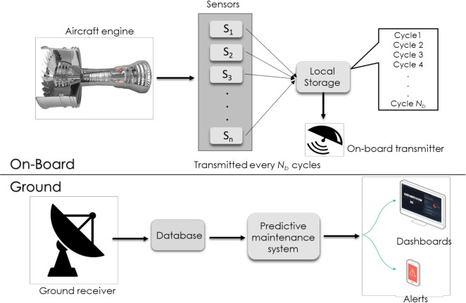

**Domain : Deep learning, false data injection attack, LSTM,GRU, CNN, industry 4.0, Internet of things, machine learning.**

**Project Description :** False Data Injection encompasses a class of malicious data attacks that target critical infrastructures controlled by Cyber-Physical Information Systems. FDIA strategies involve the attacker compromising sensor readings, so undetected corrupt data is included in calculating values and variables used to define the system state.

# Technical Description :

1. we use three state-of-the-art DL algorithms, specifically, Long Short-Term Memory (LSTM), Gated Recurrent Unit (GRU), and Convolutional Neural Network (CNN) for predicting the Remaining Useful Life (RUL) of a turbofan engine using NASA's C-MAPSS dataset.
2. The obtained results show that the GRU-based PdM model outperforms some of the recent literature on RUL prediction using the C-MAPSS dataset.
3. Afterward, we model two different types of false data injection attacks (FDIA) on turbofan engine sensor data and evaluate their impact on CNN, LSTM, and GRU-based PdM systems.
4. The obtained results demonstrate that FDI attacks on even a few IoT sensors can strongly defect the RUL prediction.
5. Our experiments reveal an interesting relationship between the accuracy, resiliency and sequence length for the GRU-based PdM models.

# Implementation

1. **. Home Screen :** Starting page of the web app look as follows :

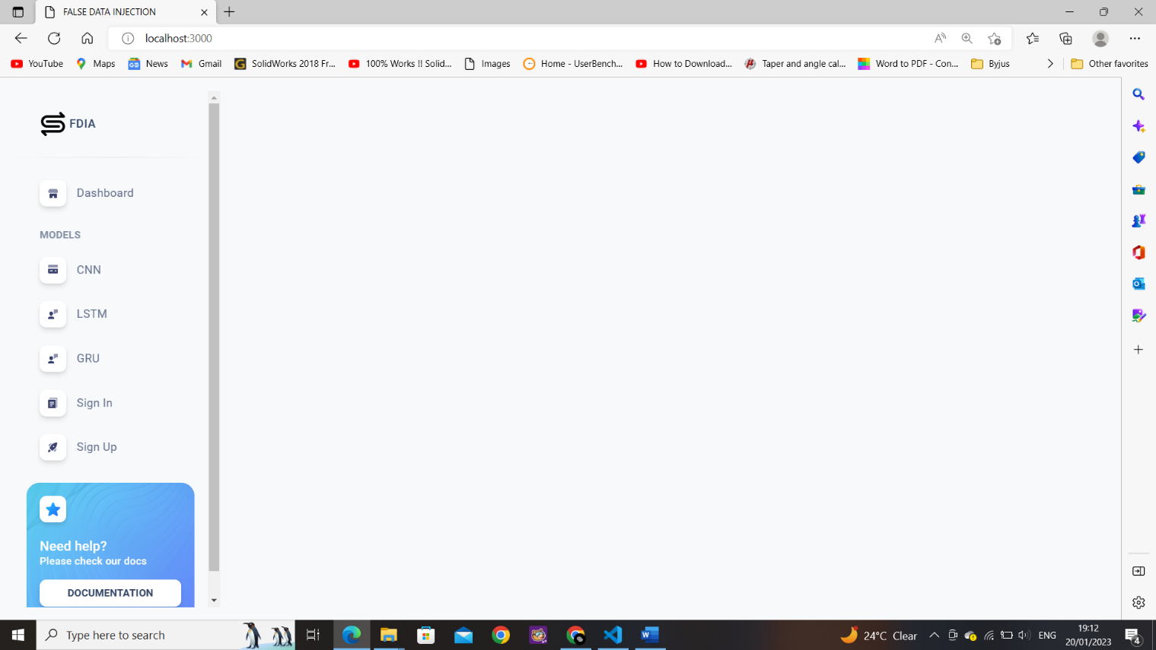

1. . **Dashboard :**It describes what is FDIA and some examples of FDIA.

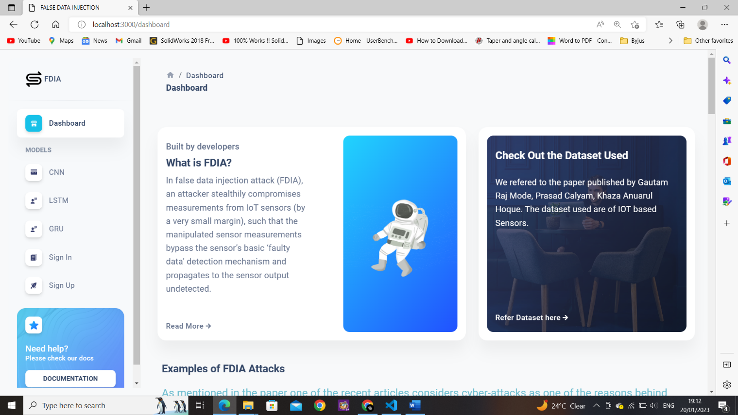

1. .**Models:** Different Deep learning modelsCNN,LSTM,GRU.



1. . **CNN :**

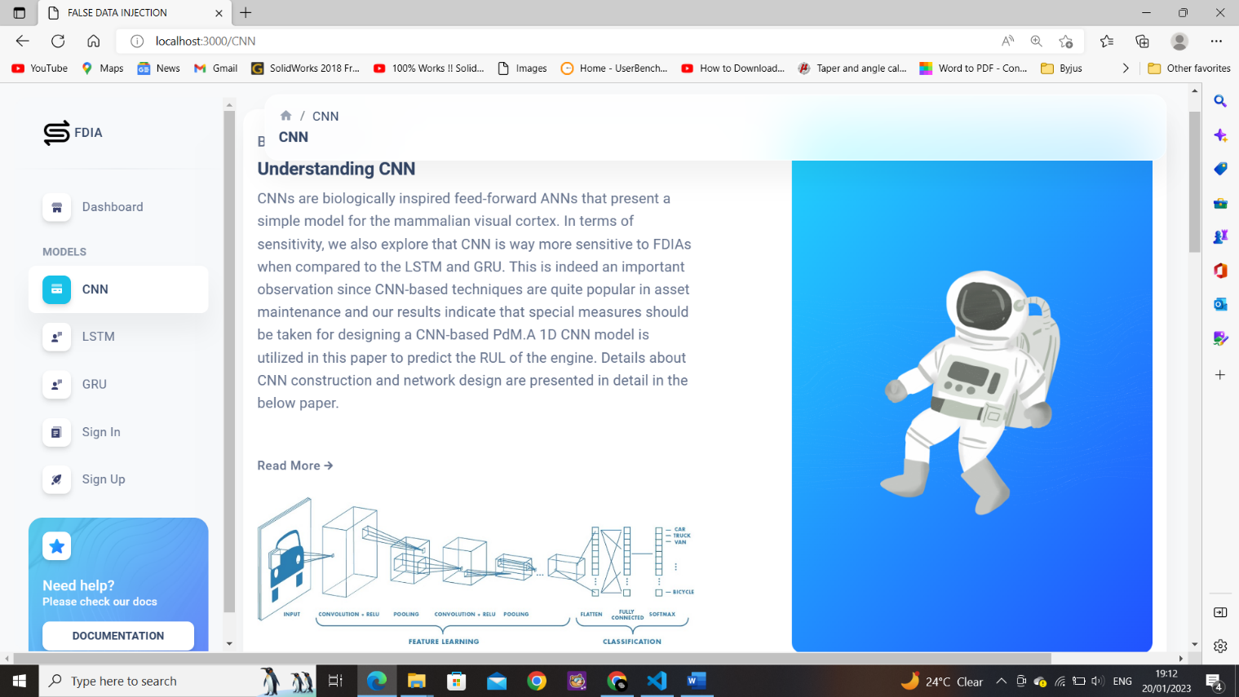

1. . **LSTM:**

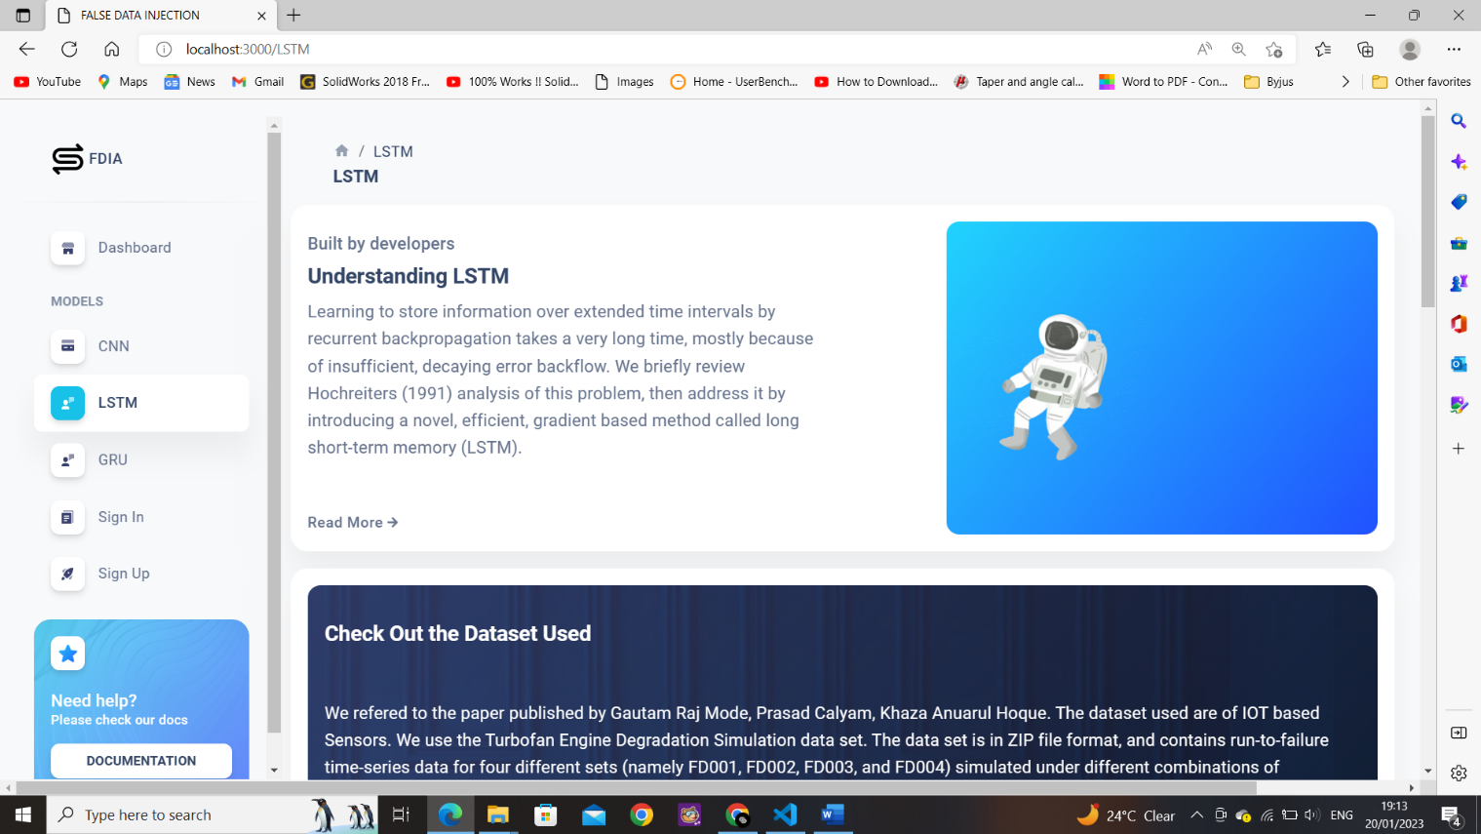

**GRU :**

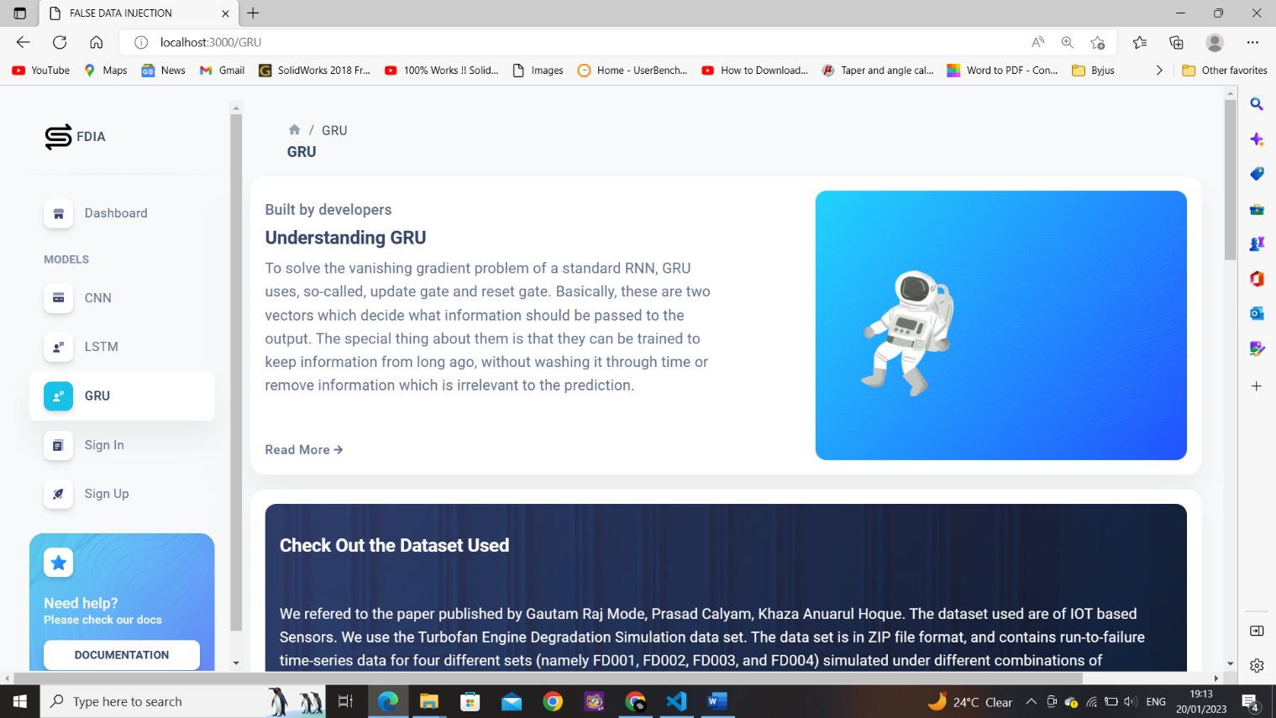

**CNN with Prediction graph :**

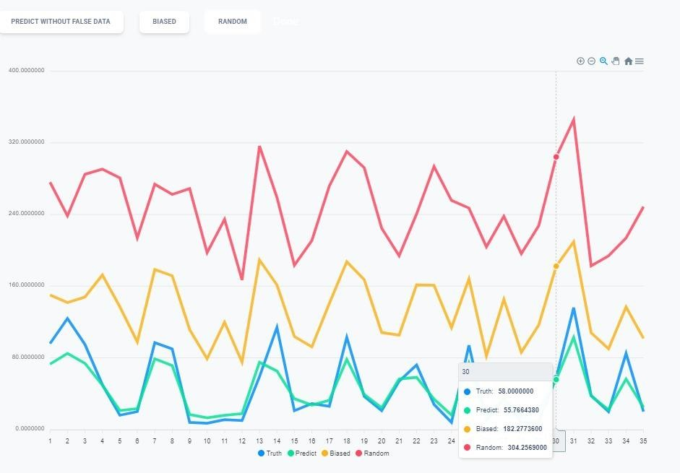

**→ Truth - Blue - true value**

**→ Predict - Green - without false data**

**→ Biased - Yellow - with False Data**

**→ Random - Red - with false data**

**LSTM with Predicted Graph:**

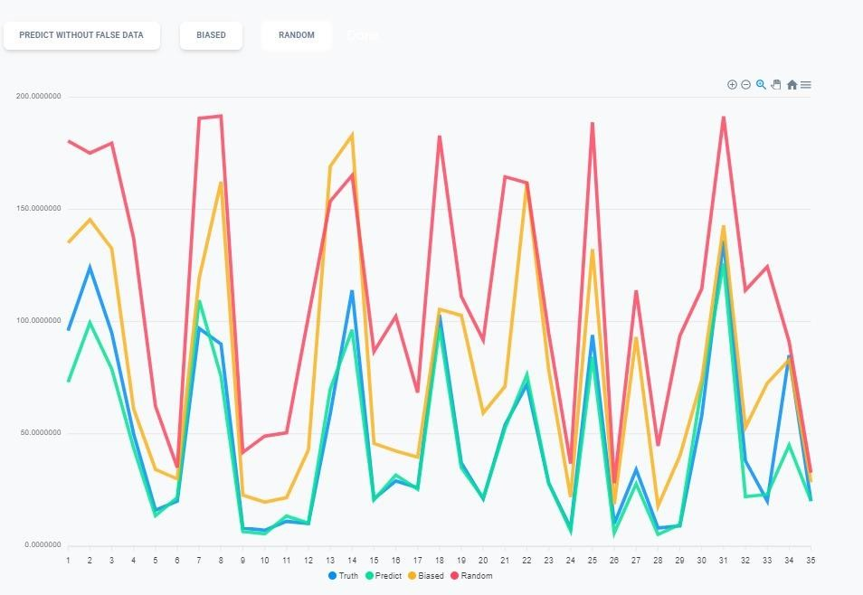

**→ truth - Blue - true value**

**→ predict - Green - without false data**

**→ biased - Yellow - with False Data**

**→ random - Red - with false data**

**GRU with Predicted Graph:**



**→ truth - Blue - true value**

**→ predict - Green - without false data**

**→ biased - Yellow - with False Data**

**→ random - Red - with false data**

**CNN Comparison table :**

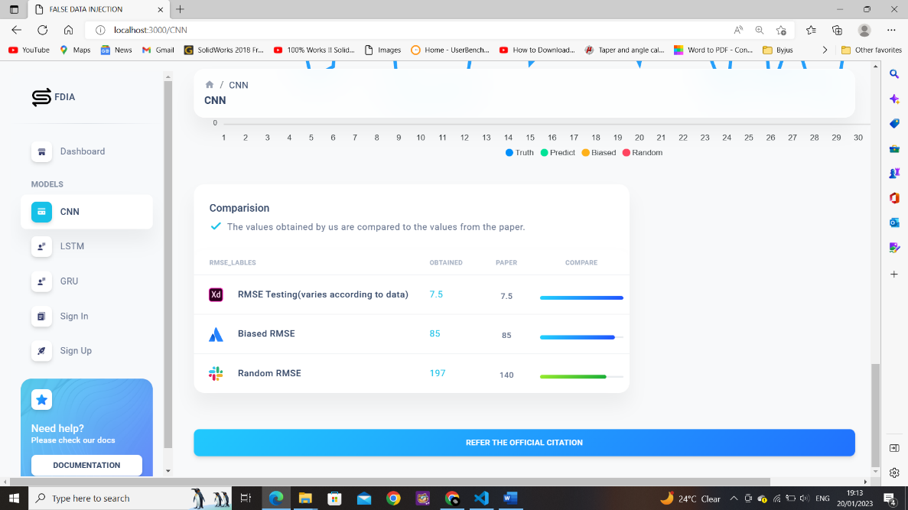

**LSTM Comparison Table:**

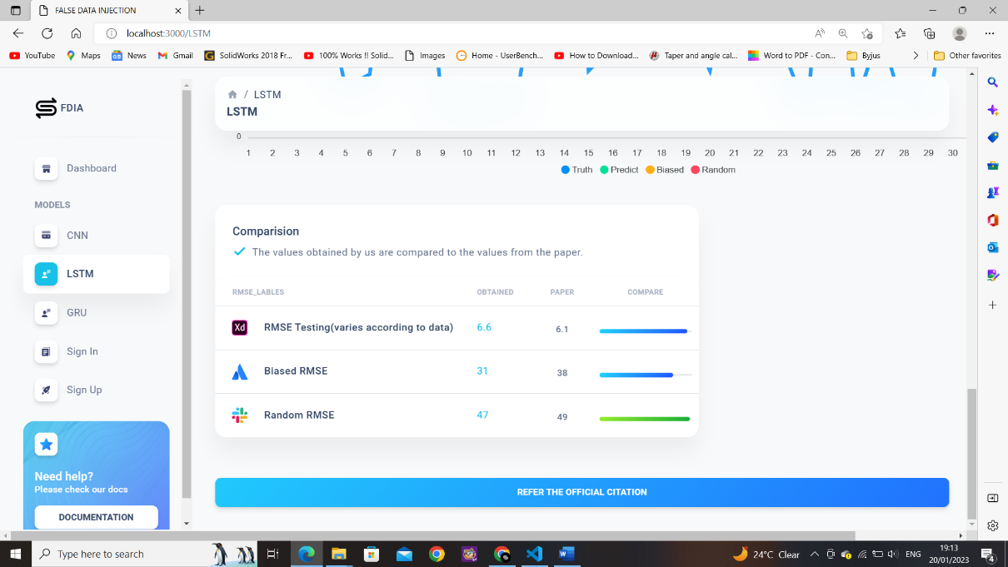

**GRU Comparison Table:**

